UHG Data LAKE

Solution ARchITecture Document

This document provides a comprehensive architectural overview of the UHG Data Lake, using number of different architectural views and patterns to depict different aspects of the overall solution.  It is intended to capture and communicate the significant architectural decisions which have been made and is a living artifact which shall be revised periodically throughout the life of the UHG Data Lake.

# REVISION HISTORY

|  |  |  |  |
| --- | --- | --- | --- |
| Date | Version | Description | Author |
| 11/01/2015 | DRAFT | Initial Draft | Vinod Balasubramanian |
| 12/30/2015 | v1.0 | Updated Use Cases | Anis Raja |
| 1/22/2016 | v2.0 | UPDATE IN-PROGRESS | Gabe Hart |
|  |  |  |  |

Table of Contents

1. REVISION HISTORY 2

2. INTRODUCTION 4

2.1 UGH Data Lake SOLUTION Overview 4

2.2 UHG Data Lake GUIDING PRINCIPLES 6

2.3 UHG Data Lake scope 6

2.4 UHG Data Lake Source System Roadmap 7

3. ARCHITECTURE 7

3.1 Key Architectural Considerations 7

3.2 UHG Data Lake Refernce ARCHITECTURE 8

3.3 UHG Data Lake Conceptual ARCHITECTURE 9

3.4 UHG Data Lake MapR OVERVIEW 9

3.5 UHG Data Lake Environment Strategy 10

3.6 UHG Data Lake INGESTION PATTERNS 10

**3.6.1** Chance Data Capture (CDC) Process 11

**3.6.2** File Transfers 13

3.7 UHG Data Lake STORAGE PATTERNS 13

**3.7.1** UHG Data Lake DIRECTORY STRUCTURE - OVERVIEW 13

**3.7.2** UHG Data Lake HIVE Storage Handlers 17

3.8 UHG Data Lake USAGE/CONSUMPTION PATTERNS 18

**3.8.1** UHG Data Lake Consumption PATTERNS - Use Case Diagram 18

**3.8.2** UHG Data Lake Consumption PATTERNS - Overview 19

4. SECURITY 19

4.1 Administration 20

4.2 Authentication 20

4.3 Authorization 20

4.4 Audit 20

4.5 Data Protection 20

4.6 Optum Big Data Platform Solution Architecture Document (SAD) 20

5. METADATA MANAGEMENT 20

6. Appendix 22

6.1 References 22

6.2 Definitions, Abbreviations, Acronyms 22

6.3 Technology Selection Rationale 23

6.4 BDPaaS Conceptual Context Diagram (CCD) 27

# INTRODUCTION

## UGH Data Lake SOLUTION Overview

The UHG Data Lake presents an organized repository for all raw/un-filtered structured and unstructured data acquired through the use of the Data Fabric capabilities. In addition, the Data Lake also presents centralized data storage for a common enrichment repository, based on contracted services, that improves the usability of data for specific client use cases which will mitigate future duplication of data while extending the reusability of the data. The following diagram depicts the overall current BDPaaS architecture in place today upon which the Data Lake resides.

**Fig. 1 – BDPaaS Reference Architecture – Current Strategy (MapR Distro of Hadoop)**



**Why the UHG Data Lake IS…**

The Data Lake is simply a cheaper more robust data architecture for storing, managing and analyzing data compared to traditional data warehouse technologies. It is often referred to as an analytics hub and spoke service architecture enabling teams to self-provision their own data sets comprised of myriad distinct data sources and entities which already reside on the Lake (note: security is discussed in detail later in this document). Much more verbose than the traditional data warehouse, the UHG Data Lake, built on MapR’s distribution of Hadoop extends the following capabilities:

* Perform advanced analytics via multiple software engineering frameworks (Spark, R, SAS, Mahout, etc..)
* Extend analytics into application development
* Expose analytics as a service to applications (API’s)
* Support integration with multiple data search, discovery and visualization technologies (and the list keeps growing)
* Integrated in-memory / in-database processing
* Ultimately provide a secure, managed and highly available view of the enterprise through a data lense

**What the UHG Data Lake IS…**

The UHG Data Lake is a large storage repository and processing engine for common enterprise data. It provides "massive storage for any kind of data, enormous processing power and the ability to handle virtually limitless concurrent tasks or jobs".[1] (*Note: the current implementation of the Data Lake is obviously constrained by the total amount of resources available on the platform, the previous statement is indicative of an aspirational state*). The concept and subsequent implementation came about to address several short comings of data warehouses and marts: “Only a subset of the attributes are examined, so only pre-determined questions can be answered." and "The data is aggregated, so visibility into the lowest levels is lost."[2] Additionally the table below illustrates the differences between a Data Lake and Data Warehouse:

**Table 1 – Data Warehouse vs. Data Lake**

|  |  |  |
| --- | --- | --- |
| DATA WAREHOUSE | **Vs.** | **DATA LAKE** |
| Structured, processed | **DATA** | **Structured/semi-structured/ unstructured/raw** |
| Schema-on-write(heavy up-front data modeling effort) | **PROCESSING** | **Schema-on-read** |
| Expensive for large data volumes | **STORAGE** | **Designed for low-cost storage** |
| Less agile, fixed configuration | **AGILITY** | **Highly agile, configure and reconfigure as needed** |
| Mature | **SECURITY** | **Maturing** |
| Business professionals | **USERS** | **Data analysts & scientists; Application developers; Business professionals** |

**What the UHG Data Lake is NOT…**

The UHG Data Lake is NOT simply a dumping ground for all data. The BDPaaS extends multi-tenancy to enable distinct entities to have both dedicated and guaranteed processing and storage for their unique business use-cases. The following guiding principles impose guardrails on the ingestion and storage of data in the Data Lake.

## UHG Data Lake GUIDING PRINCIPLES

* The Data Lake is viewed as an extension of the source (in its entirety as defined by the source)
* Data governance and usage rules defined within each source system is to be inherited
* The Data Lake (*in almost all cases*) maintains historical views of each sources data
* The Data Lake (*in certain cases*) will provide current views (*or optimized for usage*) of the data
* Data Fabric is the sole data ingestion framework for the Data Lake

## UHG Data Lake scope

**UHG Data Lake Benefits / Features:**

* **Fidelity**: Data Lake extends the source systems of record/truth by original grain and form
* **Highly Available**: Data Lake maintains both historical and current views of the data
* **Late Binding**: Data Lake lends itself to flexible task-oriented structuring which does NOT require up-front data models
* **Obsessively Managed**: Data Lake inherits governance policies from the source and extends through consumption patterns
* **Near Real-Time**: Data Lake is populated and refreshed with data as near real-time as possible via the Data Fabric framework which implements the following:
  + Common Data Acquisition
  + Generic Data Ingestion Framework
  + Centralized Storage/Archive Mechanism (Data Lake)
  + Common Data Integration and Enrichment Capabilities
  + Standard Data Provisioning

## UHG Data Lake Roadmap

## UHG Data Lake Source System Roadmap

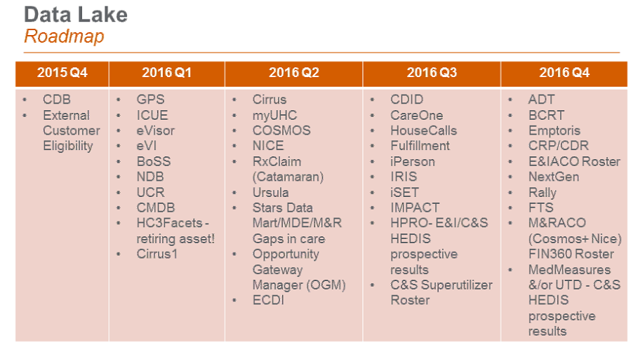

### UHG Data Lake Infrastructure

In order to support the processing and storage of the 2016 strategic agenda, the following infrastructure will be provisioned and added to the current UHG Lake Production environment. The infrastructure called out in Red will be the new infra needed.



# ARCHITECTURE

## Key Architectural Considerations

|  |  |
| --- | --- |
| Consideration | **Description** |
| Loading Data | Data Fabric will be the sole funnel of data into the Data Lake |
| Storing Data | Data brought to the Lake will be stored in its RAW format. Data enriched or optimized for consumption shall be copied to a consumption layer and stored again. |
| Processing Data | Data Fabric will be used to process all data on the Data Lake. |
| Data Governance | Data Lake will adhere to enterprise data governance policies |
| Data Security | Data Lake will inherit security from the source system |
| Metadata Management | Data Lake will capture and present operational ,business and transactional metadata for various use cases |
| Data Retention | Data Lake will retain data per source system requirements |
| Archive | Data Lake will archive data per program/project and legal requirements |
| Purge | Data Lake will purge data per program/project and legal requirements |

## UHG Data Lake Refernce ARCHITECTURE



The above reference architecture has been defined and refined with consideration for the following principles:

1. A generic solution that is vendor-neutral
2. Based on a model of standards compliance
3. Capable of being instantiated to produce intermediary architectures and real solutions
4. Promotes and facilitates IT-to-Business alignment
5. Address multiple stakeholder perspectives
6. The manner in which this reference architecture is instantiated is determined by the user
7. Uses the minimum number of layers to depict the possible combinations and elements of the Data Lake

## UHG Data Lake Multi-tenancy

A multitenant platform is a set of technologies that enable business users and processes to share a common set of resources via policy rather than physical separation while achieving desired SLA’s and without violating data security requirements or even exposing the existence of one party to another. Creating a data lake, comprised of entire sources of strategic enterprise data, as a tenant on a multi-tenant platform enables all the tenants (once authorized) to access any of these data sets without having to go back to the source system or impacting any of the other consumers of the data.

A tenant is a group of users that have the same view of the platform, this addresses workload isolation via queue’s and data segregation / quota’s via volumes. From an administrative perspective this enables SLA’s, guarantees isolation and security (by volume via POSIX and within a volume via ACEs and ACLs) and ultimately simplifies operations (as there is only 1 platform vs. many). Per tenancy policy control is achieved at the volume inter/intra level. Volumes can be created for projects, organizational entities and various prod/non-prod environments. By using a scheduler (either the fair or capacity scheduler) along with volumes we can segregate a tenant’s workload and data from another tenant. Over time, the need arises to bifurcate workload capacity within a tenant. This is accomplished via the use of sub-queue’s.

The following strategy and architecture has been developed in response to the need to segregate workloads and guarantee cluster resources by source upon ingest and usage/consumption patterns. The Data Lake hierarchical sub-queue strategy shall address the following:

* **Separation of resources** by ingestion and usage/consumption patterns
* **Consistent** **performance** for the ingestion of distinct sources as well as distinct usage/consumption patterns
* **Security** at the sub-volume level for historical and current views of the data

This strategy shall be implemented via the Fair Scheduler, which uses a method of assigning resources to applications such that all applications get, on average, an equal share of resources over time. By default, the Fair Scheduler bases scheduling fairness decisions only on memory. It can be configured to schedule resources based on memory and CPU. When only one application is running, that application uses the entire cluster. When other applications are submitted, resources that free up are assigned to the new applications, so that each application eventually gets approximately the same amount of resources. Unlike the default Hadoop scheduler, which forms a queue of applications, this lets short applications finish in reasonable time while not starving long-lived applications. It is also a reasonable way to share a cluster between a number of users. Finally, fair sharing also uses priorities applied as weights to determine the fraction of total resources that each application should get.[3]

**Benefits of this strategy include:**

* **Hierarchical Queues** - Hierarchical queues ensure that resources are shared among the sub-queues of an organization before other queues are allowed to use free resources, thereby providing more control and predictability.
* **Capacity Guarantees** - Queues are allocated a fraction of the capacity of the grid, which means that a certain capacity of resources are at their disposal. All applications submitted to a queue have access to the capacity allocated to the queue. Administrators can configure soft limits and optional hard limits on the capacity allocated to each queue.
* **Security** - Each queue has strict Access Control Lists (ACLs). The ACLs control which users can submit applications to individual queues. Also, safeguards ensure that users cannot view or modify applications from other users. Per-queue and system administrator roles are also supported.
* **Elasticity** - Free resources can be allocated to any queue beyond its capacity allocation. As tasks scheduled on these resources complete, the resources become available to be reassigned to applications on queues running below their capacity. (Note that pre-emption is not supported.) This ensures that resources are available in a predictable and elastic manner to queues, thus preventing artificial silos of resources in the cluster and improving cluster utilization.
* **Multi-tenancy** - A comprehensive set of limits is provided to prevent a single application, user, or queue from monopolizing resources of the queue or the cluster as a whole. This ensures that the cluster is not overwhelmed.

Today, the UHG data lake ingests all source data via a single “parent” queue. As new sources are implemented into the Data Lake, they compete for the same resources regardless of priority, ingest velocity or ingest volume.

If un-checked, as new sources are implemented into the Lake, which consume additional resources, additive to the already existing workloads from the same resource pool, this will inevitably cause delays in the integration of data into the Lake resulting in decreased freshness of the data, increases in latency and overall SLA impacts downstream.

To remediate these challenges the UHG Data Lake shall implement sub-queues within the Data Lake tenancy, whereby each source shall be segregated into its own sub-queues and set of “child” queues under the UHG Data Lake “parent” queue to ingest raw historical data as well as to process current views of the data when required. Each sub-queue’s will receive a proportional ratio of the parent queues allocation. As queues are arranged in a hierarchy to divide resources, they can be configured with weights to share the cluster in specific proportions. The Fair Scheduler uses a concept called a queue path to configure a hierarchy of queues. The queue path is the full path of the queue's hierarchy, starting at root.

The following example has three top-level child-queues a, b, and c and some sub-queues for a and b.

**Figure 1 – Logical Sub-Queue Design**



In the above example, queue’s a and b represent distinct sources that have been identified / implement as requiring and thus having their own queue’s. c, could be considered as a default queue where sources and jobs will run if they do not meet the below criteria.

1. Jobs must run and complete in under 15 minutes
2. Jobs must run more than once an hour
3. Jobs must process more than 100 GBs of data (subject to high swings of variability)

In order to implement this approach, **NEW** entries will need to be created into the Source Partner Profile (SPP) table, designating into which sub-queue each source shall submit its jobs, further segregated into raw, historical and current view “child” queue’s.

To expand on the security of this solution the historical raw data sets shall be processed into a distinct sub-volume, separate from the sub-volume that maintains the current views of the data. This is in part due to the limitation of POSIX which only grants a single owning security group per volume. Today, when one is granted access to the data (via the POSIX group), they get access to the raw and current views of the data in their entirety with no security. By implementing this approach the data shall be physically segregated into distinct volumes for raw historical data and current views of the data.

The below diagram depicts a logical representation of this flow into distinct volumes with visibility into POSIX level security.

**Figure 2 – Detailed Sub-Queue Design**



SUMMARY

Sub-queues enable guaranteed minimum performance and when part of a parent queue which addresses the concerns for multiple tenants also raises the ceiling for each parent queue as more tenants create sub-queue’s. Other advantages of sub-queue’s include security, elasticity and generally advance multi-tenancy for not only ingest but also usage and consumption of data from the UHG Data Lake. By extending this architecture to include the segregation of data by type, we also establish a repeatable security pattern at the volume level.

**Figure 3 – Tenancy Model Comparison**

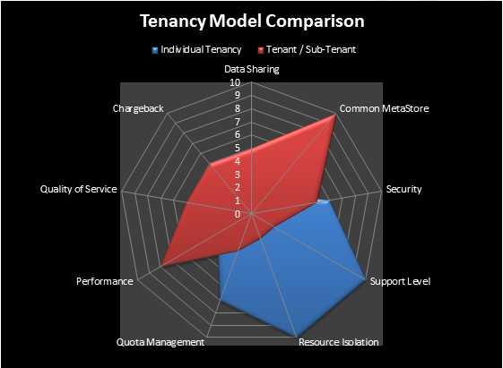

Where the interests of a new tenant do NOT align with interests of an already existing tenant, a new tenant should be created. However, when requirements for data sets are common and the benefits can be articulated for a common metastore as well as an increased ceiling of the aggregated queue quota’s, a parent queue should be considered (thus effectively increasing the potential available workload capacity to the sub-queue when the other sub-queue is not being used). There are no benefits to either approach for data sharing, quota management, quality of service or chargeback/showback model. Before proposing this, resource isolation and sla’s must be considered along with disaster recovery and support implications.

## UHG Data Lake Conceptual ARCHITECTURE



## UHG Data Lake MapR OVERVIEW

The following image displays a high-level view of the MapR Distribution for Apache Hadoop:

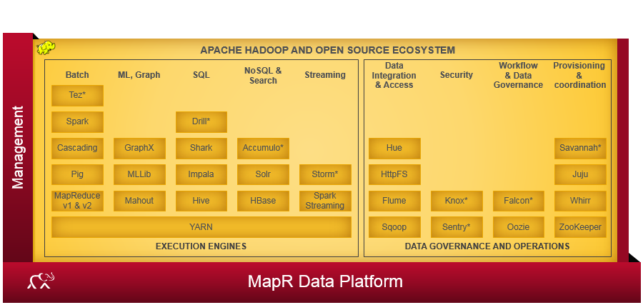

## UHG Data Lake Environment Strategy

BDPaaS provides both a Production and Non-Production platform for the Data Lake to develop, test and stage new functionality. The production environment and non-production environment are physically segregated in different data centers and disaster recovery environment is available for future build out.

## UHG Data Lake INGESTION PATTERNS

The following patterns represent the standards by which all data shall be ingested into the data lake. Note that while anti-patterns exist (e.g. transferring data to an edge node with a file transfer tool) they are not called out below. The following diagram represents a high level conceptual view of ingestion.



### Chance Data Capture (CDC) Process



#### **CDC – Use Cases**





#### **Infrastructure Use Cases**



### File Transfers

[add here]

## UHG Data Lake STORAGE PATTERNS

The following file system directory structure extends four key data lake principles.

1. Store anything
2. Retain it as long as needed
3. Support a variety of processing workloads
4. Scale

### UHG Data Lake DIRECTORY STRUCTURE - OVERVIEW

|  |  |
| --- | --- |
|  | Data Lake Folder Organization   * Some sources like CDB have both UHC and Optum. They will be at UHG level * Some sources like Nice and Cosmos have UHC specific. They will be stored under UHC folder * Some sources like Optum Rx are Optum specific. They will be stored under Optum folder. * Owners of source system will continue to own the data in Data Lake in its Raw layer. * Governance and control of source systems will be extended to Data Lake Raw. |

#### UHG Data Lake Directory Structure – RAW LAYER



#### UHG Data Lake Directory Structure – ENRICHED LAYER



#### UHG Data Lake Directory Structure – ENRICHED LAYER Details

Data enrichment is a general term that refers to processes used to enhance, refine or otherwise improve raw data.

**Categories**

1. Basic enrichment - Data cleansing/clean up; no change to the structure. E.g., correcting misspellings, removing duplicates, standardization

2. Augmented enrichment - Additional data fields added to the raw data structure and/or multiple files for the same information at different times combined to show the latest information for that source. E.g., additional identifier added, standardized snapshot created for the latest data. Note: the source table schema version folder and the partitioning folders (e.g., period folders) are optional.

3. Aggregated enrichment - Pulling in multiple sources and/or adding derived attributes; file structure is significantly different from the raw structure. E.g., symmetry grouping services: inputs are claim and member eligibility; output is member and results. Note: Symmetry is part of a broader category for processing by the Analytic Common Capabilities (ACC) platform.

* Categories 1 and 2 retain a similar file structure as the raw source data, although columns may be added
* Category 3 has a file structure significantly different from the original source data.



### UHG Data Lake HIVE Storage Handlers

Before storage handlers, Hive already had a concept of *managed* vs *external* tables. A managed table is one for which the definition is primarily managed in Hive's metastore, and for whose data storage Hive is responsible. An external table is one whose definition is managed in some external catalog, and whose data Hive does not own (i.e. it will not be deleted when the table is dropped).

Storage handlers introduce a distinction between native and non-native tables. A native table is one which Hive knows how to manage and access without a storage handler; a non-native table is one which requires a storage handler.

These two distinctions (managed vs. external and native vs non-native) are orthogonal. Hence, there are four possibilities for base tables:

* **managed native**: what you get by default with CREATE TABLE
* **external native**: what you get with CREATE EXTERNAL TABLE when no STORED BY clause is specified
* **managed non-native**: what you get with CREATE TABLE when a STORED BY clause is specified; Hive stores the definition in its metastore, but does not create any files itself; instead, it calls the storage handler with a request to create a corresponding object structure
* **external non-native**: what you get with CREATE EXTERNAL TABLE when a STORED BY clause is specified; Hive registers the definition in its metastore and calls the storage handler to check that it matches the primary definition in the other system

Note that we avoid the term file-based in these definitions, since the form of storage used by the other system is irrelevant. Hive/HBase Integration is currently supported on BDPaaS. This enables access HBase tables for both read (SELECT) and write (INSERT). It is even possible to combine access to HBase tables with native Hive tables via joins and unions.[4]

## UHG Data Lake USAGE/CONSUMPTION PATTERNS

To represent the multidirectionality of data flows to/from the Data Lake the following section describes the various consumption patterns in detail. The below diagram depicts the conceptual representation of these interactions.

### UHG Data Lake Consumption PATTERNS - Use Case Diagram



### UHG Data Lake Consumption PATTERNS - Overview

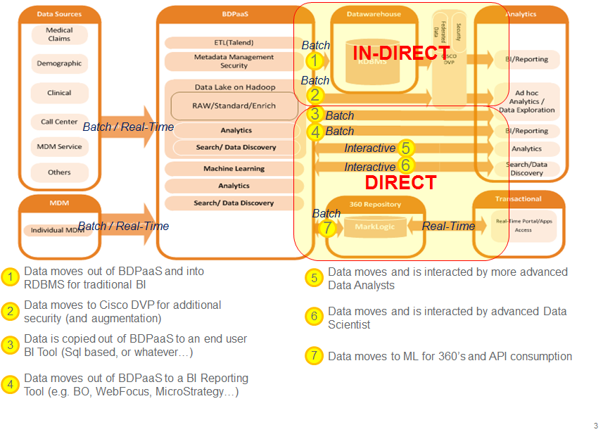

Per the Reference Architecture defined in All usage and consumption patterns fall into two types; In-Direct and Direct and three sub-types; Batch, Interactive and Real-Time. Each of these sub-types can services multiple, concurrent and non-distinct use-cases of varying security levels.

# SECURITY

The UHG Data Lake Security Architecture takes into account the main threats to a secure cluster by providing basic authorization and authentication functionality, which is extended to include Administration, Auditing and Data Protection in the UHG Data Lake:

* **File system permissions**: MapR-FS is a POSIX-like file system, permissions are managed by ownership and access is enabled by granting privileges to those groups.
* **Cluster, volume and job queue** Access Control Lists (ACLs)
* **Access Control Expressions (ACEs)**
* **Pluggable Access Modules (PAM)**
* **Hive SQL Based Authentication**

## Administration

*How to set and manage policies across the Data Lake?*

This capability is currently being researched and POC’ed with multiple vendors (e.g. Protegrity, Blue Talon, etc..)

## Authentication

*Who can access the Data Lake (users and/or systems)?*

The core component of user authentication in MapR is the ticket. A ticket is an object that contains specific information about a user, an expiration time, and a key. Tickets uniquely identify a user and are encrypted to protect their contents. Tickets are used to establish sessions between a user and the cluster. This functionality as of June 4th, 2016 is now in place on BDPaaS.

## Authorization

*What can they do on the Data Lake?*

Currently, The UHG Data Lake controls access at the source level. Meaning that if one wants access, they need to logon onto Secure and request access. All access groups begin with “Fabbp*”.

Additionally, MapR supports Hadoop Access Control Lists & Expressions, (ACLs and ACEs) for regulating user privileges to the job queue and cluster. MapR extends the ACL concept to cover volumes, a logical storage construct unique to the MapR filesystem.

## Audit

*What did they do on the Data Lake?*

MapR v5.1 will enable a feature they call “MapR Audit” which will enable auditing of operations on directories and files. The following operations on files and directories are audited:

| **Operation** | **Name in audit logs** | **Directories** | **Files** |
| --- | --- | --- | --- |
| **Change group owner** | CHGRP | Y | Y |
| **Change owner** | CHOWN | Y | Y |
| **Change permissions** | CHPERM | Y | Y |
| **Create** | CREATE | N/A | Y |
| **Delete** | DELETE | N/A | Y |
| **Disable auditing** | DISABLEAUDIT | Y | Y |
| **Enable auditing** | ENABLEAUDIT | Y | Y |
| **Get attributes** | GETATTR | Y | Y |
| **Lookup** | LOOKUP | Y | Y |
| **Create directory** | MKDIR | Y | N/A |
| **Read a file** | READ | N/A | Y |
| **Read a directory** | READDIR | Y | N/A |
| **Rename** | RENAME | Y | Y |
| **Delete a directory** | RMDIR | Y | N/A |
| **Set attributes** | SETATTR | Y | Y |
| **Write to a file** | WRITE | N/A | Y |

### Auditing of operations on MapR-DB tables

The following operations on MapR-DB tables are audited:

| **Operation** | **Name in audit logs** |
| --- | --- |
| Create a column family | DB_CFCREATE |
| Modify a column family | DB_CFMODIFY |
| Delete a column family | DB_CFREMOVE |
| Scan a column | DB_CFSCAN |
| Get data | DB_GET |
| Perform incremental bulk load | DB_IMPORTBUCKET |
| Perform full bulk load | DB_IMPORTSEGMENT |
| Put data | DB_PUT |
| Compact a table region | DB_REGIONCOMPACT |
| Look up a region on the current node | DB_REGIONLOOKUP |
| Merge two consecutive regions | DB_REGIONMERGE |
| Split a region into two | DB_REGIONSPLIT |
| Configure a replica for a table | DB_REPLICAADD |
| Edit the replica for a table | DB_REPLICAEDIT |
| List the replicas for a table | DB_REPLICALIST |
| Remove a replica for a table | DB_REPLICAREMOVE |
| Scan a table | DB_SCAN |
| Create a table | DB_TABLECREATE |
| View information about a table | DB_TABLEINFO |
| Modify a table | DB_TABLEMODIFY |
| Add an upstream source to a replica | DB_UPSTREAMADD |
| List all upstream sources for a replica | DB_UPSTREAMLIST |
| Remove an upstream source for a replica | DB_UPSTREAMREMOVE |

## Data Protection

*How do we protect the data at rest and in motion?*

## Optum Big Data Platform Solution Architecture Document (SAD)

See the most recent OBDP Security SAD in the following location.

<http://optumhealth100.optum.com/sites/ODM/TechOffice/Shared%20Documents/Forms/AllItems.aspx?RootFolder=%2fsites%2fODM%2fTechOffice%2fShared%20Documents%2fODM%20Technology%20Strategy%2fOptum%20Big%20Data%20Platform%2fSecurity%20Architecture&FolderCTID=&View=%7bB91404A0%2d395D%2d40AB%2d99F7%2dE73E195DFB41%7d>

# METADATA MANAGEMENT

Metadata is the keystone of the Data Lake. Whether technical, business or operational metadata, it enables search, discovery, optimizes usability, informs security policies, data governance and ultimately is the sole barrier between a Data “Lake” and a Data “Swamp”.

Link to Metadata repository.

<https://dbsep1070:8443/MetaAccess/>

[Add link to MetaData SAD here (when available)]

# Appendix

## References

|  |  |
| --- | --- |
| Artifact Name | **Location** |
| Project Requirement Document | [http://optuminsight200.optum.com/sites/OMS/datafabric/Shared%20Documents/Forms/AllItems.aspx?RootFolder=%2fsites%2fOMS%2fdatafabric%2fShared%20Documents%2f4%2e0%20%2d%20Projects%2f4%2e4%20Data%20Fabric%20Pilot%2f3%2e0%20Planning%20Analysis%2f3%2e1%20Business%20Requirement%20Documents&FolderCTID=&View=%7bC5F2BA61%2d7FDB%2d430C%2dB236%2d3FB755110CB8%7d](http://optuminsight200.optum.com/sites/OMS/datafabric/Shared%20Documents/Forms/AllItems.aspx?RootFolder=%2fsites%2fOMS%2fdatafabric%2fShared%20Documents%2f4%2e0%20%2d%20Projects%2f4%2e4%20Data%20Fabric%20Pilot%2f3%2e0%20Planning%20Analysis%2f3%2e1%20Business%20Requirement%20Documents&amp;amp;FolderCTID=&amp;amp;View=%7bC5F2BA61%2d7FDB%2d430C%2dB236%2d3FB755110CB8%7d) |
| BDPaaS Platform Architecture | <http://it-etp-wss.uhc.com/sites/SWES/sesprogmgmt/NGISBDPaaS/DAaaSPublic/Architecture/NGIS%20BDPaaS%20Solution%20Architecture%206.0.pdf> |
| Optum ODM Intranet | <http://inside.optum.com/our-companies/optum/solutions-and-technology/optum-data-management/> |
| Presentations on Data Fabric | <http://optumdocs2.optum.com/sites/OMS/datafabric/Shared%20Documents/4.0%20-%20Projects/DF%202.0%20-%20Calhoun/2.0%20-%20Product%20Definition/Data%20Fabric%202.0.ppt> |
| Data Fabric Release Documentation | <http://optumdocs2.optum.com/sites/OMS/datafabric/Shared%20Documents/Forms/AllItems.aspx?RootFolder=%2fsites%2fOMS%2fdatafabric%2fShared%20Documents%2f4%2e0%20%2d%20Projects%2fDF%202%2e0%20%2d%20Calhoun%2f4%2e0%20%2d%20Releases%20Documentation&FolderCTID=&View=%7bEB2A0F77%2d5414%2d4C2E%2d93F2%2d71430D15672C%7d> |
| Data Fabric Solution Architecture Documentation | http://optumdocs2.optum.com/sites/OMS/datafabric/Shared%20Documents/4.0%20-%20Projects/DF%202.0%20-%20Calhoun/4.0%20-%20Releases%20Documentation/Release%203/Data_Fabric_2.0_SAD_Release_3.pdf |
| MapR Security Documentation | <http://doc.mapr.com/display/MapR/Security+Guide> |

## Definitions, Abbreviations, Acronyms

|  |  |
| --- | --- |
| Term or Acronym | **Definition** |
| Hadoop | Open Source software for reliable, scalable distributed computing |
| HDFS | The Hadoop Distributed File System (HDFS) is a distributed file system designed to run on commodity hardware. The differences from other distributed file systems are significant. HDFS is highly fault-tolerant and is designed to be deployed on low-cost hardware. HDFS provides high throughput access to application data and is suitable for applications that have large data sets. HDFS relaxes a few POSIX requirements to enable streaming access to file system data. http://hadoop.apache.org/hdfs/. |
| BDPaaS | Big Data Platform as a Service |
| Data Fabric | Part of Optum ODM Organization building solutions for commercial and corporate data consumers on Big Data Platform |
| Tracking ID | A special tagging mechanism performed by ETL to track the records brought to the system and helps auditing the data processing on the records if there is any issue |
| MDM | Master Data Management, to provide a single golden record for a data subject or assign unique IDs for a person, provider or an entity |
| ECG | Electronic Communication Gateway |
| TLZ | Transient Landing Zone |
| CDC | Change Data Capture (Incremental Data Acquisition Pattern) |

## Technology Selection Rationale

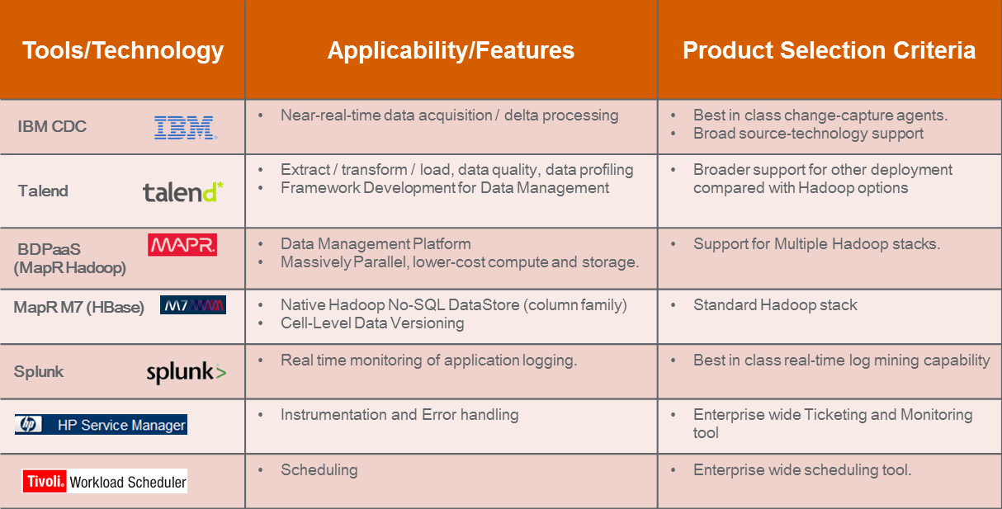

1. **IBM CDC as a Near Real Time Data acquisition processing:**

* IBM Change Data Capture (CDC) replicates your heterogeneous data in near real time
* Provides captures changed data directly from database logs rather than querying the database, hence low impact data on the server
* Provides flexible, simplified data delivery
* Integrates with IBM and other systems to enhance existing platforms and support broader information management processes.

**Key use cases for IBM CDC tool:**

* Capture data in real-time from database logs
* Deliver batch files in DF Landing zone
* Manage source data capture and delivery subscriptions through management console
* Integrate with HPOM to notify on failures
* Ingest data in real time to the speed layer
* Write directly to Mark Logic for the CDB Cloning POC

1. **Talend as ETL on Hadoop:**

* Combining big data technologies into a unified open source environment simplifying the ETL and processing of large and diverse data sets
* Graphical abstraction layer on top of Hadoop applications to generate code
* Run transforms inside Hadoop
* Native support for HDFS, Sqoop, HBase, Mahout, Pig, Hive and MapReduce Code generate
* Convert various source formats -  text, csv, dat etc - to XML
* Ingest and convert multiple files at same time
* Implement 1:1 joins in source files at time of ingestion
* Implement 1:M joins in source files at time of ingestion(limited capabilities)

**Key Use Cases for Talend**

* Log metadata for all the activities
* Manage workflows from tool
* Notifications for all the activities
* Connect to any data source (table, file or message) with any data content pattern and ingest data/metadata into HDFS.
* Identify Schema changes and track changes of meta file run over run and notify changes
* Compare Current Data Set with Previous Cycles Data Set for identifying Duplicates
* Validate data against the Control file and perform record count re-conciliation
* Assign a unique number to each record in data set.
* Convert any data content pattern (XML,JSON,HL7,837 etc.) into AVRO format
* Maintain compatibility with readers and writers during schema changes(data type, add/delete column, re-name) over period of time
* Create an external Hive table on Master AVRO Schema
* Standardize Dates, Address, Phone along with few basic Data Validations (Not Null on Key Fields
* Identify new records compared to previous dataset(s) and output only new records
* Create an external Hive table
* Extract Data from Different data content patterns(Hive)
* Execute external Scripts like HQL, Pig, Java,  MapReduce
* Join Multiple Data Sets, Multiple Tables, Hive and Teradata tables
* Summarize on a Dataset
* Execute SFTP Process to transfer files to NAS Landing

1. **HBase as Metastore for processing:**

To facilitate Metastore driven execution the following components are captured:

* Capture Source Partner Profile related Information listed below but not limited to:
  + Partner Description, Master Unique Index, etc.
  + Delivery Channel (Table Extract, Push, Message Queue, etc.)
  + Number of Entities
  + Entity Schema Definition, etc.
* Capture Source/Consumer Integration Profile related Information listed below  but not limited to:
  + Enrichment (MDM, ACC, Data Quality configuration).
  + Data Quality rule definitions, etc
* Capture Provisioning Partner Profile related Information but not limited to:
  + Consumer Partner Description
  + Transmission Channel (Push, Publish, etc.)
  + Sources, etc.
* Capture Run time Process Metadata:
  + Checksums (Schema, Data File, etc.)
  + Record count and Dollar (Paid, submitted charge, etc.)  reconciliation
  + Logical Process Failures (Schema Validation, Duplicate File  Check)
* Capture Metrics :
  + Process Start time, End Time, Total time taken to complete a process.
  + Log Failures
* Audit Logging :
  + Capture Request files.
  + Capture Responses i.e. (which source data was provisioned out to which consumer and when)

**Key Use Cases:**

* Metadata driven workflow execution i.e. ability to choose capabilities that need to be executed for a partner.
* Ability to define Partner information (read/write)  via a web User Interface.
* Ability to dynamically create Entities during run time  (Read and Write)
* Ability for application process to query metadata and make decisions during run time.
* Track what are various sources and targets (Partners) sending data to and consuming data from Data Fabric.
* Capture Lifecycle of a file processed through the framework.

1. **Splunk as an Operations Log Miner:**

* Collects Operations events and Workflow execution Logs and Indexes them
* Provides real time ‘Search’ Capability on top of all Logs
* Visualization/Analysis/Mining Capabilities that will support Operations and Analysis teams to identify:
* Operational Intelligence
* What sources sending what type of data
* What is delivery channel
* USPS type tracking for each batch/file/dataset (Inbound/Outbound)
* Configurable User Interface to perform various statistical analysis on Log data
* Built in Security to control access by user type

**Key use cases:**

* Track what are various sources and targets (Partners) sending data to and consuming data from Data Fabric
* Answer critical operations/data governance related questions:
* How many files/records received from a given source on a specific date/timeframe
* How many records/How much volume processed by particular capability (MDM, Integration, Provisioning, DQ and so on)
* If a particular workflow executed successfully or not
* Total time taken to execute a process/workflow/capabilities by source/file/batch/dataset
* Who is consuming what data (Data Usage analysis)
* Create historical data processing dash board
* Monitor cluster strength
* Do we need to add additional nodes to cluster?
* Support flexible log formats (JSON) and not worry about transforming content before mining

## BDPaaS Conceptual Context Diagram (CCD)

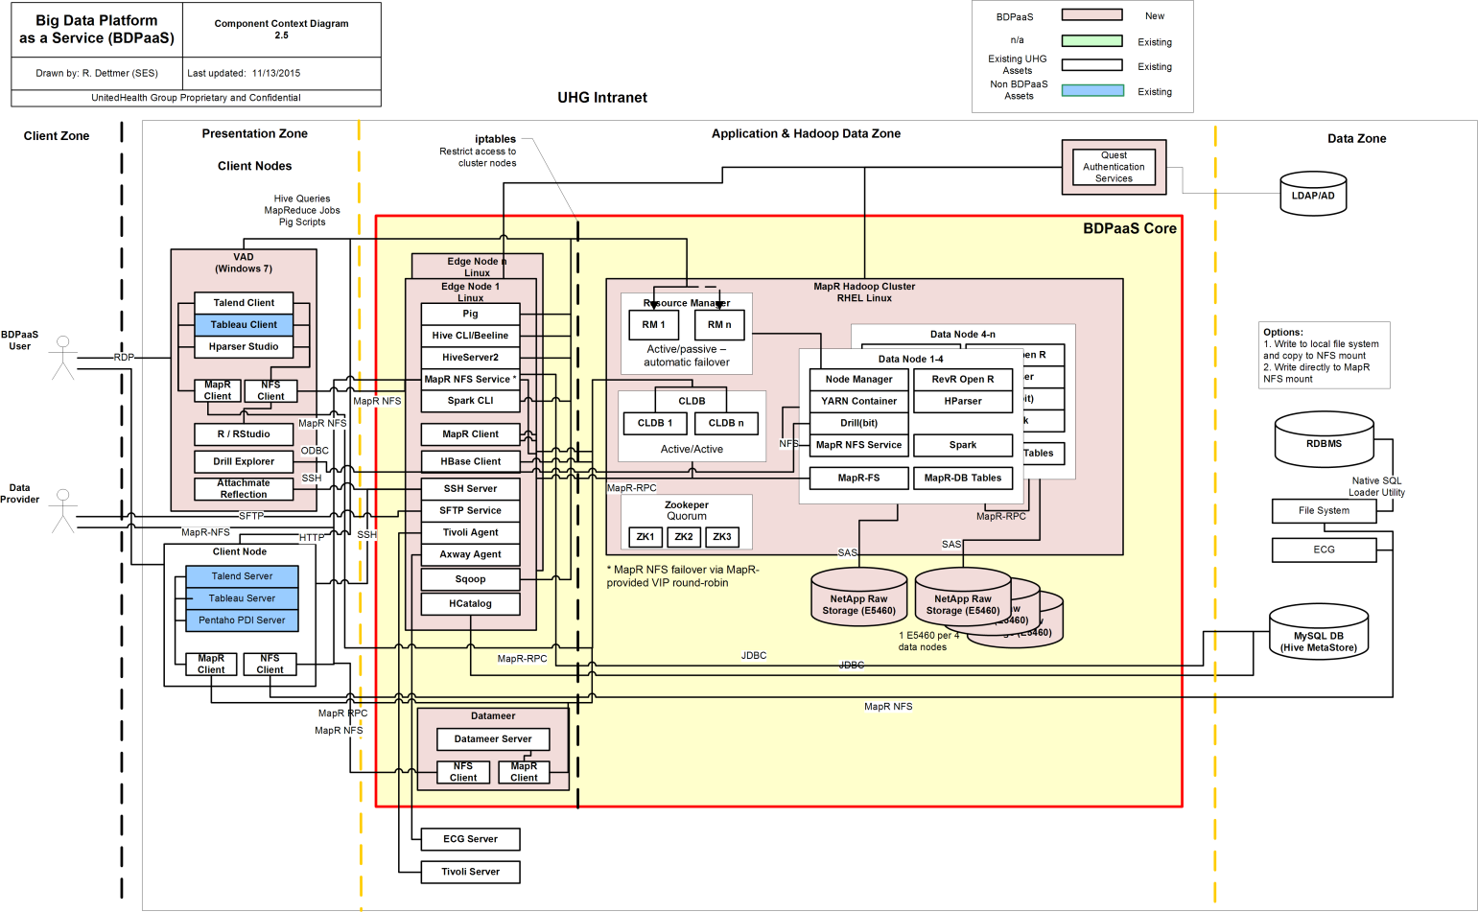

1. [What is Hadoop](http://www.sas.com/en_us/insights/big-data/hadoop.html); SAS;
2. Dixon, James; “[Pentaho, Hadoop and Data Lakes](https://jamesdixon.wordpress.com/2010/10/14/pentaho-hadoop-and-data-lakes/)”; James Dixon’s Blog
3. Hadoop 2.x Fair Scheduler - http://doc.mapr.com/display/MapR/Hadoop+2.x+Fair+Scheduler
4. HBaseIntegration - https://cwiki.apache.org/confluence/display/Hive/HBaseIntegration#HBaseIntegration-HiveHBaseIntegration